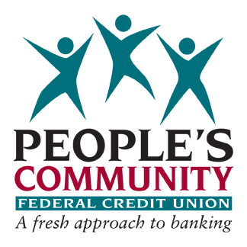

People’s Community Federal Credit Union Internship Program

PCFCU’s Internship Program is a wonderful opportunity for students to work “hands on” in a casual yet professional business atmosphere. The purpose and goal of the Internship Program is to assist in the development of the student by teaching them essential skills that will help pave the way to their working future. During this program, the Intern will learn and understand the purpose and philosophy of the credit union. This program also provides students the opportunity to experience, learn, and apply the fundamentals of a working relationship with coworkers and members.

REQUIREMENTS

Interns must meet certain set criteria in order to participate in this program:

- Age requirement of 15 – 17 years of age
- Student (or parents) must be members of the Credit Union for at least 6 months
- Must be a student in good standing
- Must maintain a minimum grade point average of 3.0
- Must be able to work a minimum of 15 hours per week
- Must possess a desire and willingness to learn, grow, and strive
- Submission of a completed Participation Packet

There is a formal application and interview process for all those interested in participating. Space is limited for each scheduled program; only a set number of candidates will be accepted. In addition to submitting an application, candidates will be required to provide a current school progress report along with a 250-word essay on why they would like to participate in the program.

SCHEDULE

The program will have a beginning and end date. This summer the program will run from
June 24, 2024 – August 16, 2024.

At the beginning of the program, Interns will be required to submit a schedule of available dates and hours for the duration of the program, listing all scheduled vacations, camps, sport activities, school programs, and/or appointments that will limit their availability. Once a schedule is submitted and approved, an Intern will be expected to commit to their schedule with the exception of an emergency or illness. All intern schedules and schedule changes are
subject to approval by the CEO of the Credit Union to ensure they meet the staffing needs of the Credit Union. Interns will be paid at minimum wage, which is currently $16.28 per hour.

TRAINING & EDUCATION

Interns will be given one-on-one training by the Credit Union. In addition, Interns will be required to complete three on-line training courses. These courses are designed to teach the intern the important facets of a credit union and the servicing of its members.

COMMUNITY SERVICE

The credit union participates at the Clark County Fair by sponsoring the Courtesy Booth. During fair week, August 2nd - August 11th, Interns will be expected to volunteer for 12 hours of community service (unpaid) to be performed outside of their working schedule. Interns volunteer in the manning of the Courtesy Booth, which offers fair patrons a place to check their packages while spending the day at the fair.

If you are interested and would like to receive an application packet for the program, please contact Amy Hotchkiss or Sheri Erickson at 360-695-5121 by May 17th.

